

11.17.14

COPELAND STREAM ‘IXORA’ IN FULL


After the rumor mill spun with talks of a Copeland reunion and the actual announcement of the first album the band has released in six years, we have finally been given the long-awaited Ixora.

Around here, this has been one of our most highly anticipated releases of 2014, as every single album this band has put out is just a glorious listening session. Aaron Marsh’s beautiful voice may resemble what angels sound like.

The band has put the full stream of the album up on Spotify a week before it’s released. Could this be the comeback of the year? Album of the year? Well, let us know what you think, and stay aware for our full review coming soon.

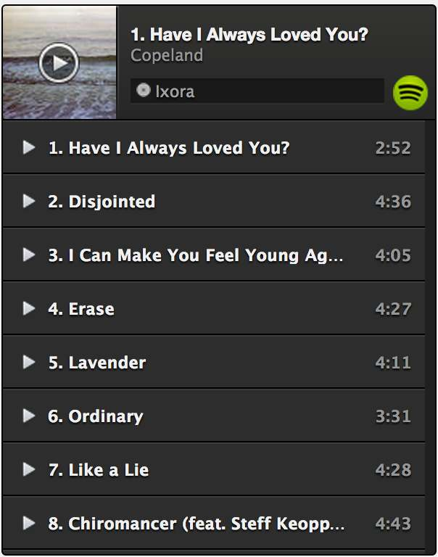
Check out Ixora below.

Ixora will be released on November 24 via Tooth and Nail.

http://www.underthegunreview.net/2014/11/17/copeland-stream-ixora-in-full/

