

11.20.14

A Gift From Copeland: Former High-Profile Lakeland Band Reunites to Record Album

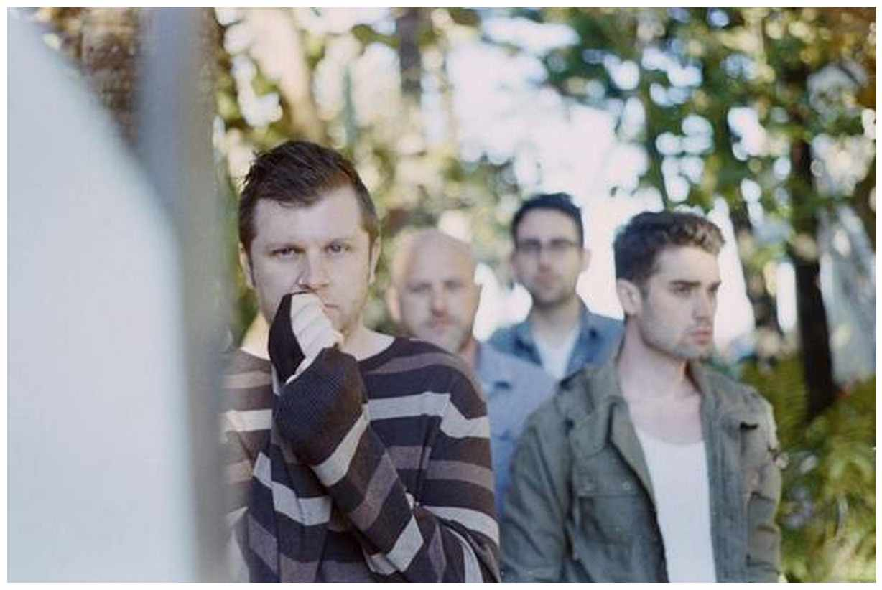

LAKELAND-BASED alternative rock band Copeland reunited to record a new album, “ixora,” and perform two shows. in its heyday, the group was getting notice on the Billboard charts and touring with national acts. (PROVIDED BY COPELAND)...



http://www.theledger.com/article/20141115/ENT/411155005

