
11.20.14

Copeland Makes a Comeback with New Album ‘Ixora’
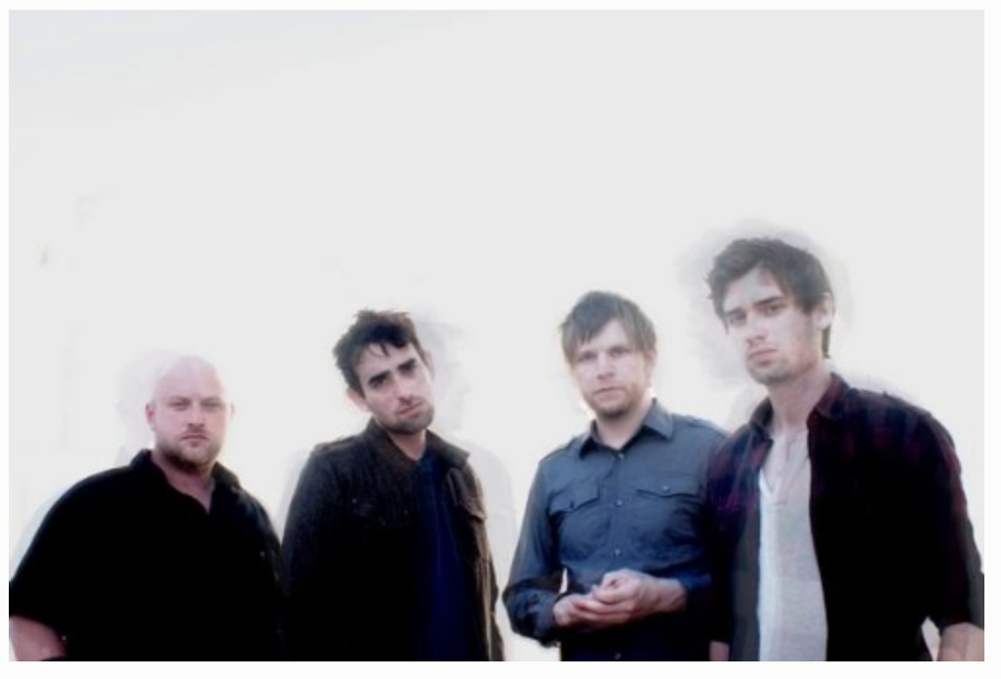
This post is going to brief, but I wanted to recommend Copeland's new album Ixora. I've been listening to it on Spotify for days now, but apparently it's only available through iTunes on November 24th. Despite the strange release times, this new music is unimaginably good. Here's the kicker: the band broke up in 2008. Ixora was never intended to exist, and came from a spontaneous bout of passion. This is news in and of itself that put a smile on loyal fans' faces... and then we all actually had a chance to hear the beauty that is Ixora.

I'm a sucker for lyrics. I write poetry and find myself loving music 1000x more if the words that pull it together are so smoothly constructed they drip off your tongue when you sing along. To lure in some lyric loving non-Copeland fans, I'm posting the lines that especially struck me.

Be prepared to have your jaw drop and eyes widen over the poignancy of these.

"You're still a breeze upon my skin, close my eyes, breathe you in. I'm still a shadow in your night, taking over until I fade into your light." -Erase

"Your breathing is quickening; take my lungs, I owe you. Lost and cold, now there's a place in my arms I can keep you. A billion stars and here we are." -I Can Make You Feel Young Again

"In a world of chaos, she could be your silence. The oceans of her kindness, they will pull you under." -In Her Arms You Will Never Starve

"Right now I can't go on, when all our foolish words are falling in the way." -Lavender

"In the back of your mind, everyone was watching and no one cared at all. In a never ending loop of time, the quiet washed over me." -World Turn

"If only I could call up through the void to reach you, if only I could stretch across the depths to hold you, if only for a moment I could make two parts a whole, if only for a moment I could rest beside your soul." -Chiromancer

http://www.thecreativitychronicles.com/blog/ixorabestlyrics

