

11.19.14

INTERVIEW: Copeland Discuss the Long Journey to ‘Ixora’

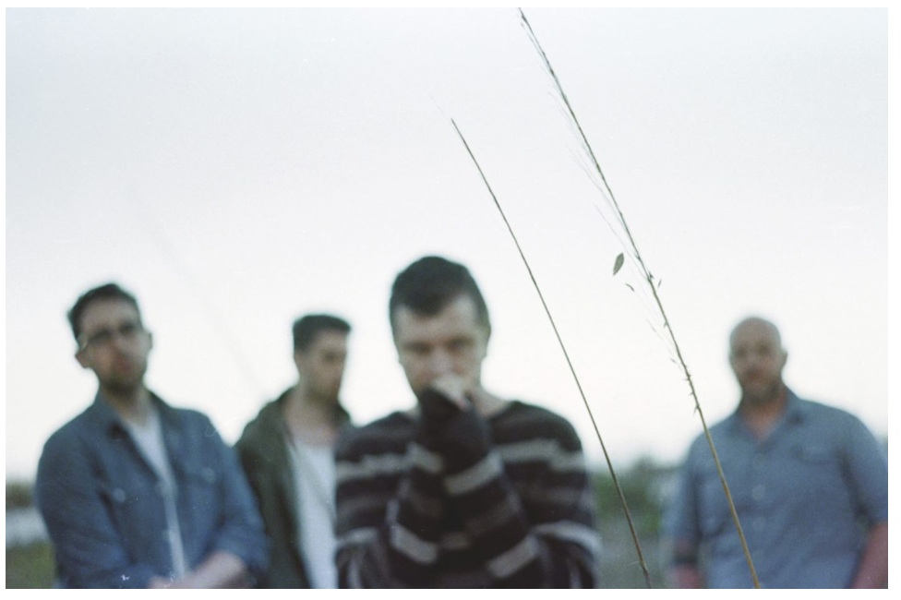
Read our extended interview with Copeland vocalist, Aaron Marsh, originally cut and published in issue 41.

Substream Magazine: After almost six years, why did you guys decide that now was the right time to come back?

Aaron Marsh: Well, they went off and did the States band after Copeland broke up, and I think one thing that was kind of inspiring to them was the States Kickstarter. It did real well. They raised over their goal and they got lots of comments wanting a Copeland record as well. They actually first broached the subject with me. I had always wanted to do another record since before the last tour. They wanted to do a final tour. I wanted to do a final record. That was the way that things were left. They weren’t too impressed with that, because doing another record opens up a lot of other questions like, “Will you tour on the record? What’s the point in doing a record if you’re not going to go out and work it, sell the record and tour on it?” So, I think that was why they were hesitant all along. I think now it just seems like a good time.

I have a folder of song ideas from like 2009 that in case we did another record I had some demos, which some of those we’re using; some of those we’re not. I’ve felt really incomplete about our recorded works for a long time. I felt like we hit our stride on the last two records. I don’t feel like I fully explored everything that we could have done with the sound that we settled on. So, it was really something I wanted to do.

But as for why now, all of our lives lined up between band members and it seemed like a good time to do it. And we didn’t want to wait too long. We’re learning that as people grow up and get families they don’t really care about stuff that they cared about when they were younger, as is the case with us. We thought while we still have an audience we should maybe do something. So, that was another factor.

SM: I’ve seen that a lot of people have latched on to the fact that Anberlin is breaking up and you guys are reuniting and are hoping that you two do a joint tour, but you’ve always said that touring was out of the question. Do you still hold that position or can fans expect to hear the new songs live?

AM: I don’t know. We’ve talked about what a live show aspect would look like for our band and our personal lives right now. I think we’ve come to the conclusion that full-on touring is not in the cards with families and business. Our drummer has a new business. He designs and sells furniture. He has a pretty crucial business. I have a business and a family. Bryan has a family. His wife just started a business. Three of us are homeowners. I think for us right now, full on touring – like hopping in a van for six weeks – is not going to happen.

What could conceivably happen is one-off shows and little weekend trips. I think we feel there should be some sort of live aspect if we’re doing a record, and [since] we finally own our own record for the first time in our career. It would be silly to not do any shows, but as far as hopping in a van and playing every city possible, that’s not real close to ever happening again.

And the Anberlin thing is a super big coincidence. Maybe it’s a coincidence or maybe it’s just the life cycle of things. We clocked out and they were doing a lot better and kept going. Then when they felt it was time to wrap up was about the time we were getting curious to get back into it. I don’t know if it’s a complete coincidence or just the cycle of the music industry.

SM: I know I’ve noticed a lot of people talking about how you’re doing production on their last record so maybe you’ll join them on a tour.

AM: Honestly, it would be really stupid of them to bring us, because they’re going to sell out all the rooms on their own. We would be a really expensive support band, just because we could probably fill the rooms or come close to filling those rooms on our own. So, honestly it wouldn’t be a very good economic move for them. They need to make their money and go out with a bang and have a little money for all the guys to start something new. That’s really what they need to do. They need to save money, because they’re all going to want to launch new businesses or new careers or buy a house or whatever after they settle down. So, they shouldn’t be taking schmucks like us on tour with them, spending all their money.

SM: So, after doing all this production over the last few years, how does it feel to be making another Copeland record again, instead of just making other people’s music?

AM: Oh my gosh, that’s a huge thing, because all this time I’ve been using all my good ideas on other people’s music. I really don’t work on any music that I don’t want to work on and I don’t like. Then when I get into it, I really get into it. I don’t hold back ideas. I don’t have an idea for a part and say, “Umm I’m just going to save that for my record.” I just go full-force on the records that I produce. So, yeah it’s cool. It’s cool to have ideas and think that it’s actually going to be on my music instead of someone else’s.

It’s just exciting to get back into writing again, because honestly it’s been a long time since I wrote songs. I have this experimental hip-hop project in my off time, which I don’t really have much off time, but it’s called The Lulls in Traffics. Most of that I was just writing instrumental music and then I was working with a rapper and he would rap on it and I would sing a hook or do one verse. My writing was really minimal and I got comfortable not having to write lyrics and sing too much. So, it’s been cool to get back into it. I was definitely a little rusty on the writing side, but I’m feeling good. I’m feeling inspired. I’m feeling good about the stuff that I’m coming up with for the Copeland record for sure.

SM: Where are you guys at right now with the whole process?

AM: We are still in writing mode, and writing mode for me is sort of tracking mode too, because I’m working with all the same tools that I write with as what I’ll be doing the record with. There’s some stuff that’s tracked, but a lot of it I’ve been holding back until the guys get here. Stephen will be here in two weeks and Bryan will be here another week after that. Jon lives here. So, we’re sort of in writing mode, but some tracking and stuff.

SM: You guys are doing this completely as an independent band. I know that affords you more creative license, but is it difficult not having that major label backing you and knowing you’ll have that monetary support there?

AM: Honestly, creatively we’ve always pretty much been able to do what we want. The most anyone ever interjected their creative opinion, as far as from a label, was on the tracklists. We made three records for Militia Group and then one of those got up streamed to Columbia. So, technically we weren’t on Columbia when we made it. Then the last one was for Tooth & Nail and they let us do whatever we want. So, creatively we’ve always been able to do what we want.

The thing that was nice about being on a label was we didn’t really have to worry about the money aspect. I think it puts you in a different headspace when you have to worry about where the money for a particular thing is coming from. Before we would say, “Oh, we want to record strings on this,” and we would just ask the label and if they said yes, they said yes. If they said no, then never mind. That’s probably the biggest difference. Now we think about what we want and we figure out how we’re going to get the money to get it. It’s not so much of asking someone yes or no. It’s like, “Well, can we make this happen or not?”

SM: Sonically – I know you haven’t recorded it yet – but what do you think we can expect from the new record?

AM: The last two Copeland records – Eat, Sleep, Repeat and You Are My Sunshine – they kind of have a similar sonic signature. I think we’ll probably stay in that wheelhouse, but try to expand in a couple different directions. I would like to have more electronic stuff, but also more organic stuff, if that makes sense. I know it doesn’t really make sense, but having songs that feel more electronic and then having songs that feel more organic than even any of the past records did – more simple. So, basically just trying to expand our dynamic range and not having a record that sounds moderately electronic, somewhat organic, trying to push the limits in what we do in either realm so that we have a broader sound. That’s the super nerdy producer talk version of it.

SM: Do you think the single, “Ordinary,” is any indication of how the record will sound?

AM: Yeah, I think so. I mean, that songs’ really simple. There will be some simple stuff. There will be some stuff with layers. Some of the demos are heavily electronic. Who knows if they’ll turn out that way when we eventually finish them up.

We’re doing a bonus disc, the Ixora Twin Version is what we’re calling it, that will have all sorts of bonus tracks and will also have a bonus disc that will play like a remix record or like an alternate version of the record. They will be able to play in sync. So, if you have two CD players you can hit play on both CD players at the same time and hear a third version of the record, which would be both at the same time in four speakers.

So, that’s also been forming our arrangements a little bit. We want to make sure that it doesn’t turn into a total cluster fudge when you play both of them. I think in the back of our heads we’re going to be thinking about when we’re recording one version what’s happening in the other version. So, there’s a little bit of that too. We have a few little boundaries we’re setting on ourselves so that they can be played together and so it’ll work to do both.

SM: That’s pretty cool. I don’t know if I’ve ever heard of anyone else doing that.

AM: I haven’t heard it, but supposedly there’s a Flaming Lips record in the 90s that had something like that. But I’ve never heard it. I just kind of heard about it when I was in high school. From my understanding, it’s fairly abstract. I’m hoping to make a pretty cohesive listen for all three ways.

SM: What’s the significance to the album being named Ixora?

AM: The significance probably won’t sound all that significant to say it. The Ixora flower is a tropical flower. My family and I bought a house. I had a kid and had another kid. One of the ways that I coped with a bunch of life changes was I planted this crazy, tropical garden all around my house. So, that flower is really just significant of that period of time. That’s one of the first ones that I planted and the garden really just represented a place of serenity for me when I was going through some life changes. It’s highly significant for me, but probably not all that significant of a story. It’s just representative of a time marker for me.

SM: Yeah, so it’s something really personal for you. Of the songs that you’ve written so far, what kinds of concepts do you explore lyrically?

AM: I wrote a good bit about my family and my kids. I don’t have nearly the amount of the heartache and drama that I had when I was younger. I always try to tap into that when I need to write something that sounds longing. Laughs Probably the bulk of it is based around my family and my kids.

SM: Do you think a song is more powerful when it’s written from your own perspective as opposed to writing from someone else’s perspective?

AM: No, I don’t think so. I think the fact that you’re writing from someone else’s perspective means that perspective was important enough to you. There was a relatability there that struck you. That’s why you decided to write from that perspective. So, I actually think it’s equally personal, even if it’s not your own experience – something that was important enough to you to bother writing a song about or to inspire something. I think it has just as much power.

I do that all the time. I might be technically writing about someone else’s experience, but it relates very substantially to some feeling or emotion that I had or some experience I had in the past. I think people should do that more often. I think I should do it more often: write from other people’s perspectives. It always has a way of flipping the perspective as a way of changing the attitude about what you’re writing. It makes for more dynamic songs.

SM: I guess instead of being so introspective it’s a broader perspective, but at the same time it is introspective.

AM: For me personally, I’ll take someone else’s perspective and then I’ll try to internalize it and relate it to something in my life. I can’t write in non-introspective. I can’t write in an outward looking way. It comes across either cheesy or judgmental or inspirational. Laughs I always like to keep it fairly turned inwards, but I think it’s just my style. I appreciate bringing other life experiences from other people and trying to put myself in their shoes.

SM: What is the writing process for you? How do you go about writing for a song?

AM: Usually it starts with a single line, a single hook, or it could be anything else. It could be a drum groove. It could be a base line. I could be a progression. I don’t really have any set rules for how it starts, but then you have to take it one part at a time. Lyrics are always inevitably the last thing to fall into place for me. That’s my least favorite part, just because I don’t consider myself to be a naturally good lyricist. I really have to work on it. Even then I don’t think I’m where I’d like to be.

I’ve gotten to record some artists in the last couple years that just have some slamming lyrics. Some of these guys write some really cool stuff. I’m kind of jealous of some songwriters I’ve recently worked with from a lyric writing standpoint.

SM: I think that’s funny, because I’ve spent a ton of time listening to your lyrics and I love them. I know with me, I always hate everything that I write. I’ve found that a lot with people who make any kind of art or write for a living. It seems to be a common theme that everyone hates what they produce.

AM: Yeah, I think I have a good knack for melody. I’m not like a slamming guitar player or anything. I know I have knack for putting a song together, but the lyric writing is tricky for me. I have to work at it. But I appreciate that you like them. Thank you.

SM: Sure thing. What are some goals, professionally, that you’re still hoping to achieve?

AM: I don’t know that any of the goals that I still have are all that realistic. I feel like I’ve done everything that is realistic for myself. Like, I’ve always wanted to have a song on the radio, but it’s not like we’re making Top 40 pop records. So, I don’t think that’s really going to be a reality for me. I’ve always wanted to play on TV on a late night show. So, that could theoretically happen one day, unless something crazy happens, probably not with Copeland. Maybe I’ll get to play bass for a band that plays on TV sometime.

I think a big part of when we broke up was we felt like we’d done a lot that we wanted to do. Your definition of success changes when you get into it. We hit all our goals. So, I think that was one of the factors that went into our breaking up.

SM: When you look back on it do you ever regret breaking up or do you still see that as a decision that you’re glad you did?

AM: No, we did what we had to do. Honestly, the farewell tour went well for us, but things weren’t going well for us necessarily before we announced the break-up. We were having trouble getting on support tours. We oversaturated the US touring-wise. Every record was selling less and less. So, we didn’t want to continue to fizzle out. We were just like, “Let’s go out while we’re still on a high note and do one more tour. Do a victory lap and call it a day.” So, yeah I think we definitely made the right choice. We’ll see if doing another record is the right choice.

SM: How have the pre-orders gone so far? I was looking at the website today and I saw that the top package is completely sold out.

AM: We didn’t really know what to expect out of the pre-orders, and they did really well. We didn’t know what to expect, but we knew what we needed to raise to make the record that we wanted to make and to get the mixer that we wanted to get and have a budget for string players and horn players – all the expenses that you incur when you’re making a record. You Are My Sunshine, I think we spent like $80,000 on that record. Not that we have to spend $80,000, because I don’t think we’ll spend that money on this record because we’re doing it at my studio. We wanted to raise enough money to make a record the way we wanted to make it, because any record we make now is messing with our legacy because we could have gone out on You Are My Sunshine. I feel like that was a really strong record to call it a day on, but this nagging to make another record has always been in the back of my head. I feel like I have more to say and more to do. So, we decided to take the risk and see what happened.

So, yeah the pre-orders went off. It was awesome. The first three days were just slamming. In the first three days we got two thirds of the way to our overall goal, and we still have like six months left before releasing. We totally freaked out about how awesome that went. It went really well. I don’t have a single bad thing to say about it.

SM: It’s funny, I heard someone say the other day, “Oh, well they can’t need that much money because they’re doing it all at Aaron’s studio. So, there can’t be that many expenses.”

AM: Well, there are. We live all over the country, right? The mix is a big part of the budget. Mixers are expensive. We spent $20,000 on the mix for You Are My Sunshine, and that was a hook-up. Just because I own a studio doesn’t mean it’s free for me to use.

SM: And still you want to be paid for your labor costs as well.

AM: Yeah, of course the band members want to make money again. We all have other things we could be doing with our time.

SM: Time is money, right?

AM: Yeah, but I mean we feel very fortunate to have raised the money that we’ve raised and to have the kind of fan base that will buy a record six months before it’s released. It’s crazy. Before it’s even recorded, people are buying the record. Someone got a tattoo of the Ixora logo tattooed on the back of their calf.

SM: Wow. That’s awesome!

AM: I was like, “Okay, I’ll definitely make it good. You will be proud of that tattoo. Don’t worry about it.” But yeah, super cool. I mean, we’re a lucky bunch to have the kind of fans that we have.

SM: What do you think the plan is over the next year? What do you think it’s going to look like for Copeland?

AM: There will probably be some one-off shows here and there, but no big tours. If the record starts doing well we’ll probably put money into some music videos and try to have as much of a real release as we can, being that we’re not a full-time touring band. We’re somewhat limited because we’re not going to tour a lot, but we want to do what we can as far as doing videos. People love the online performances, so that might be a possibility. We’ll do what we can, as [much as] a bunch of old dudes in a band can.

SM: I know this is completely looking into the future, but do you think this will be the last Copeland record ever? What are you thinking?

AM: I can’t really say. If people wanted to buy more records – if it seemed like there was more of a demand after we do this – I wouldn’t be opposed to doing more Copeland records. Like you said, it’s totally [looking into the future]. Who knows? Maybe we’ll totally blow it and people will be like, “Oh, maybe they should’ve clocked out after You Are My Sunshine.”

SM: Do you think that if you don’t make another Copeland record after this you’ll still be making music? You’ve had the past six years to write, and I’m sure after this record you won’t stop writing.

AM: I was going to try and release The Lulls in Traffic record this year too, but it doesn’t look like I’ll have time. Well, maybe I will. But if it’s not this year, it’ll be early next year. It’s pretty much done. It just needs to be mixed, and we just needed some money to get it finished up. Maybe if the Copeland record does really well I’ll have money to finish the Lulls record. I still plan on doing more stuff with The Lulls in Traffic too. It’s the most fun I’ve ever had making music. Ivan Ives is the rapper. We just have a great time. He’s become one of my best friends. He and I will do music indefinitely I think. There’s no pressure. I produced a couple tracks on his last solo record. So, we’ll probably continue to work together.

Who knows what else I’ll do? I don’t really want to make a solo record, but I might colab with some other people or do some other stuff. I plan to keep making music. I’m not really good at anything else.

SM: Is there anything else you’d like to say, maybe something I missed or just something you’d like to add?

AM: We’re going to try to be a little more present on social media while we’re making the record, posting pictures and clips. So, Facebook and Twitter will probably be the hub of that. We’re going to try not to be reclusive like we always are when we make records.

http://substreammagazine.com/2014/11/interview-copeland-discuss-the-long-journey-to-ixora/

