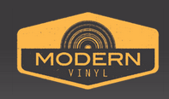

11.17.14

Copeland puts new album up for streaming


Ixora, the upcoming full length album from Copeland, is now available for streaming through Spotify. The album is going to be the subject of an upcoming “Roundtable” on The Modern Vinyl Podcast, so I won’t go too deep into my thoughts, but I’d say it’s of their best, but not quite on You Are My Sunshine level.

What does everyone else think?

http://modern-vinyl.com/2014/11/17/copeland-puts-new-album-up-for-streaming/

