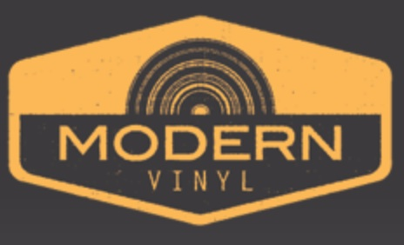

11.21.14

The MV Podcast 030: Copeland – Ixora (Roundtable)


For this week’s episode of The Modern Vinyl Podcast we talked the new album from Copeland, titled Ixora. We did all fall on one side, but I think you’ll still be interested in the lyrical themes we pulled out, how we compare it to the band’s past output and what exactly we’d skip on repeat listens. We also take a ton of reader questions, all Copeland based.

And of course…the theme song!

Timeline

5:47, Beginning of our roundtable on Ixora
— 6:50, Overall thoughts on the record
— 11:17, The lyrical theme, according to Chris
— 12:50, Favorite Tracks
— 17:55, The lyrics behind “Ordinary”
— 28:21, Future Skips
36:00, Reader Questions
42:15, We devolve into a talk about 10-year tours
48:05, Our after credit scene, aka we forgot to talk the vinyl details

Music

Courtesy of Copeland and Tooth & Nail Records. Pick up their album at iTunes. We’ll keep you updated on any more vinyl pressings.

Want to sponsor an episode?
Our sponsorships are affordable to both big and small entities, whether you’re a record label, vinyl retailer or just interested in vinyl records and what we have to say. You can contact us at advertising@modern-vinyl.com for more information. You receive a couple mentions, including a full pitch at the beginning of the episode.

http://modern-vinyl.com/2014/11/21/the-mv-podcast-030-copeland-ixora-roundtable/

