

11.6.14

Copeland Stream “Erase”


Copeland are streaming “Erase,” off their upcoming Ixora album, out November 24. Check out the stream on Soundcloud.com and pre-order the album on iTunes.
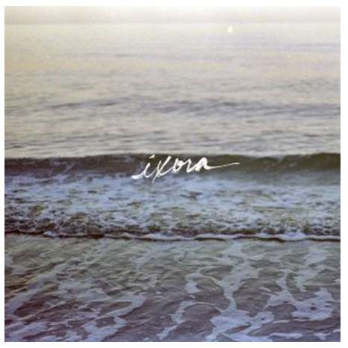

http://highlightmagazine.net/2014/11/06/copeland-stream-erase/

