

11.18.14

ALBUM REVIEW: COPELAND – IXORA



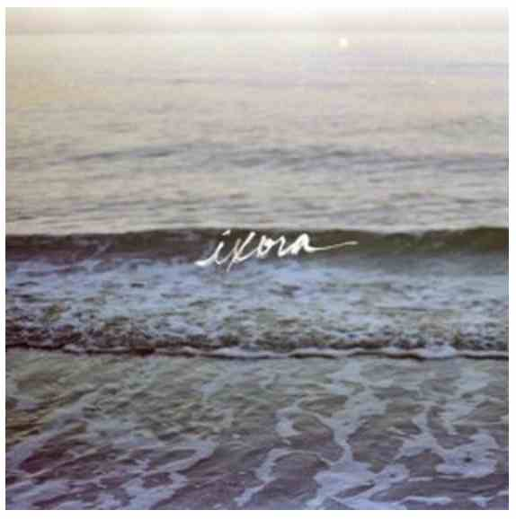
COPELAND – IXORA
LABEL: Tooth & Nail
Buy On iTunes HERE
Listen On Spotify HERE

When Copeland first announced they were going to reunite to make their fifth album, Ixora, word of it spread across the internet like a viral cat video. The moment pre-sale orders became available for the album many package deals were sold out within days, even without a release date in the books. This partly stems from the band’s seemingly sudden hiatus announcement which came only a couple months after releasing 2008’s You Are My Sunshine. (The other part of it stems from the fact that Copeland create gentle yet powerful music that is increasingly hard to find among today’s scene.) The hiatus felt somewhat temporary, though, after singer Aaron Marsh provided fans with plenty of hope that Copeland would return one day to give us another melodically dense album to make us weak in the knees.

And return they did.

It doesn’t take long to realize that Copeland have provided us with the most appropriate chapter in the Copeland catalog. Ixora is equal parts signature and new. The first few songs sound like the obvious next step for the band. You can hear the subtle atmospheric programming introduced on 2006’s Eat, Sleep, Repeat and the harmonies and vocal-heavy production that infect every previous album while also hearing some very new influences, especially on the R&B-inspired “Like A Lie.” Some fans may be disappointed to, again, hear none of the punk-ish, gritty guitar work from the early records, but it must be noted that Copeland are not that kind of band anymore, and haven’t been for a long time. There is, however, some very cool guitar sounds on “Chiromancer,” one of the more upbeat songs on the record, and with guest vocals contributed by Steff Koeppen.

Copeland today sound much like they did before the hiatus, but with an even more simplistic, mature approach. It’s ego-less, with each member of the band contributing their piece with discipline to make each song live up to its highest potential. There is no doubt that Marsh’s vocal prowess remains the focal point of the album, but only because his voice is so pure and original that it would be a crying shame to hide it. Marsh’s amazing ability to write cleverly insightful lyrics and execute them with a powerful yet intimate voice is heavily showcased on Ixora, but one of the most intimate moments on the record is the jazzy saxophone solo on “World Turn,” a relaxing acoustic ballad that sounds both romantic and tragic. The album is then capped by the soft yet uplifting track “In Her Arms You Will Never Starve” which shows Copeland’s signature ability to use unconventional instrumentation to add a unique spin on a traditional pop melody.

Copeland have released yet another album that shows how musicians can collaborate and create incredible music that comes from humility, and choosing elegance over flash. Ixora is a graceful album and exactly what we hoped to get from the reunited Copeland.


http://www.eatgeekplay.com/album-review-copeland-ixora/

