

11.7.14

Copeland Releases Stream of “Erase” From Forthcoming Album IXORA

Copeland returns reunited and triumphant with the sound of powerful new music, off their first release in six years, Ixora. Several tracks are floating around on the internet, seeping through Soundcloud and via their announcement video below, YouTube.

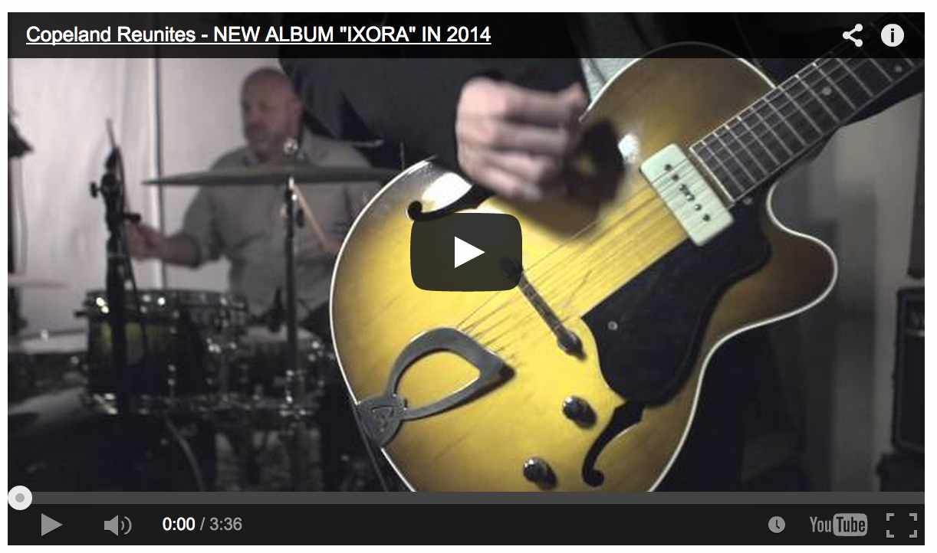

In this simple announcement, the band states, “It’s been almost six years since Copeland has released new music. Though each member has been pursuing new ventures, inside and outside of the music industry both collectively as well as individually, Aaron Marsh, Bryan Laurenson, Stephen Laurenson, and Jonathan Bucklew have reunited to record and self-release their 5th full-length album, Ixora. The record will be recorded and produced by Aaron Marsh at his studio in Lakeland, FL, The Vanguard Room.”
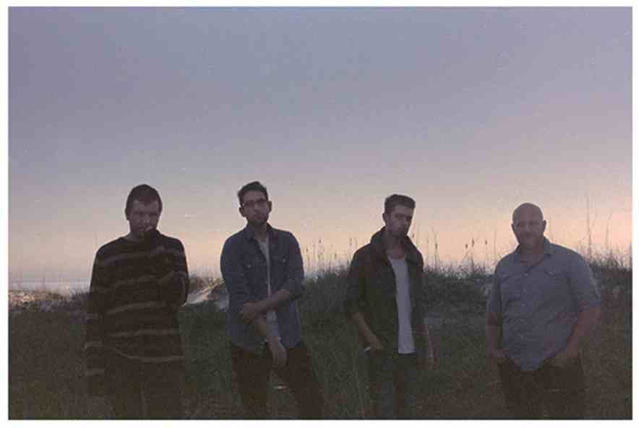
Few new millennia indie bands were able to capture the simple sweetness of life, its currents and stormy tides, as Copeland. If you’re unfortunate enough to not have heard any of their four albums previous, grab a cup of hot coffee, settle down your thoughts, press play, and enjoy the emotional journey. Copeland sprang out of a time when melody, lyrics, and emotive musicianship were key in exploring the depths of indie rock. They’ve brought the best of themselves forth once more, and we’re looking forward to the rest of Ixora, available November 24, 2014.

http://concertblogger.com/2014/11/copeland-releases-stream-erase-forthcoming-album-ixora/

